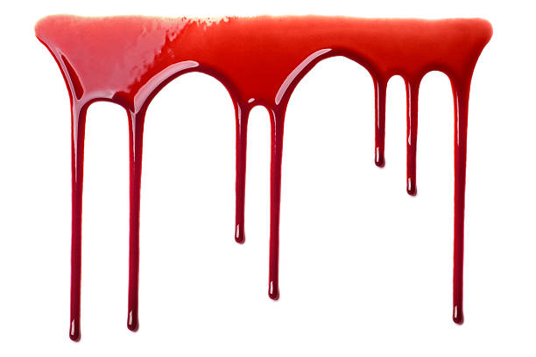
5:30pm start

Poldice Valley Halloween Horse & Hound
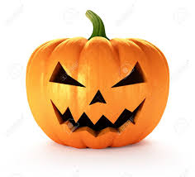
Class 1 – 50cm -60cm Jumping
Class 2 – 50cm -60cm Horse and Hound
Class 3 – 70cm -80cm Jumping
Class 4 – 70cm -80cm Horse and Hound
Class 5 – 90cm -1m Jumping
Class 6 – 90cm -1m Horse and Hound
Entries £10 or £9 for members.
Entries on the day
Rosettes for Fancy Dress

